

CS 1-B (SP26-BCS-062)
Muhammad Haider Akbar

Assignment - 2
CSC101
(AICT)

Q1: Types of Test Data
A developer testing an examination results program needs to verify that the software handles all possible inputs correctly. There are three categories of test data used to thoroughly validate a system:

(a) Normal (Valid) Test Data
Normal test data consists of typical, expected inputs that fall within the acceptable range for the program. The system should accept and process these values without errors.
Purpose: To confirm that the program produces correct results under standard conditions.
Example: A student score of 75 out of 100. Here, 75 is valid test data.

(b) Abnormal (Invalid / Erroneous) Test Data
Definition: Abnormal test data consists of inputs that are outside the acceptable range or of the wrong data type. The system should reject these values and display an appropriate error message.
Purpose: To verify that the program correctly detects and handles invalid inputs without crashing or producing incorrect results.
Example: Entering a score of -5 (negative number), 150 (above maximum)

(c) Extreme (Boundary) Test Data
Definition: Extreme test data consists of values that are at the very boundary of the valid range the lowest and highest permissible values. These are technically valid but test the limits of the system.
Purpose: To ensure the program works correctly at the edges of its acceptable range, where off-by-one errors and boundary mistakes are most common.
Example :If valid scores range from 0 to 100, then the extreme test values would be exactly 0 (minimum) and exactly 100 (maximum). Both are accepted and are called Extreme / Boundary test data

Q18: SP02YACHTS.csv

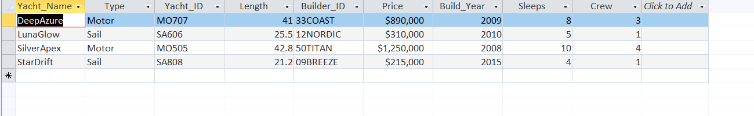
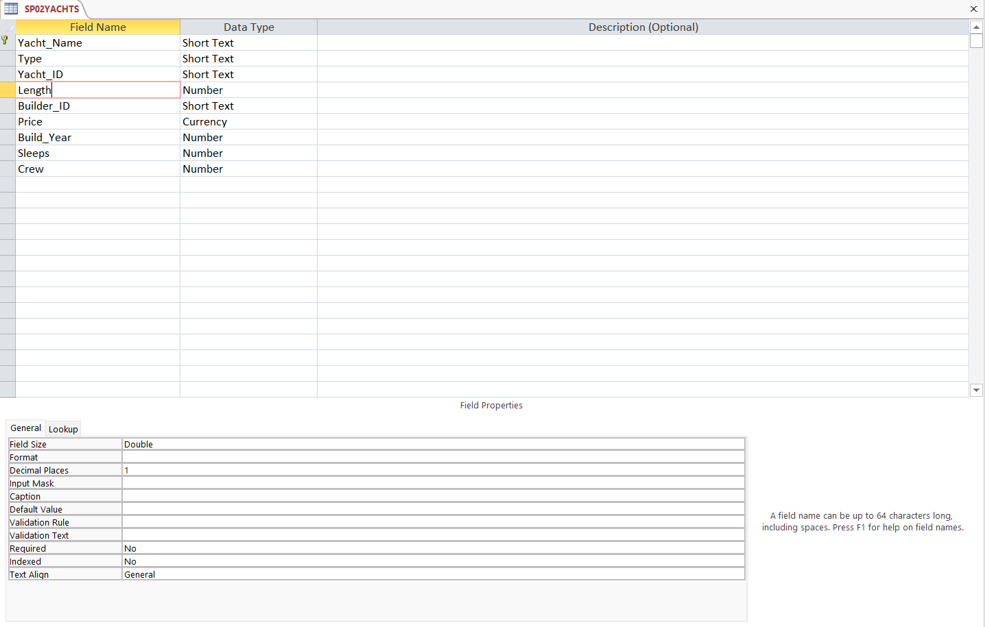

Q19: SP02BUILDERS.csv

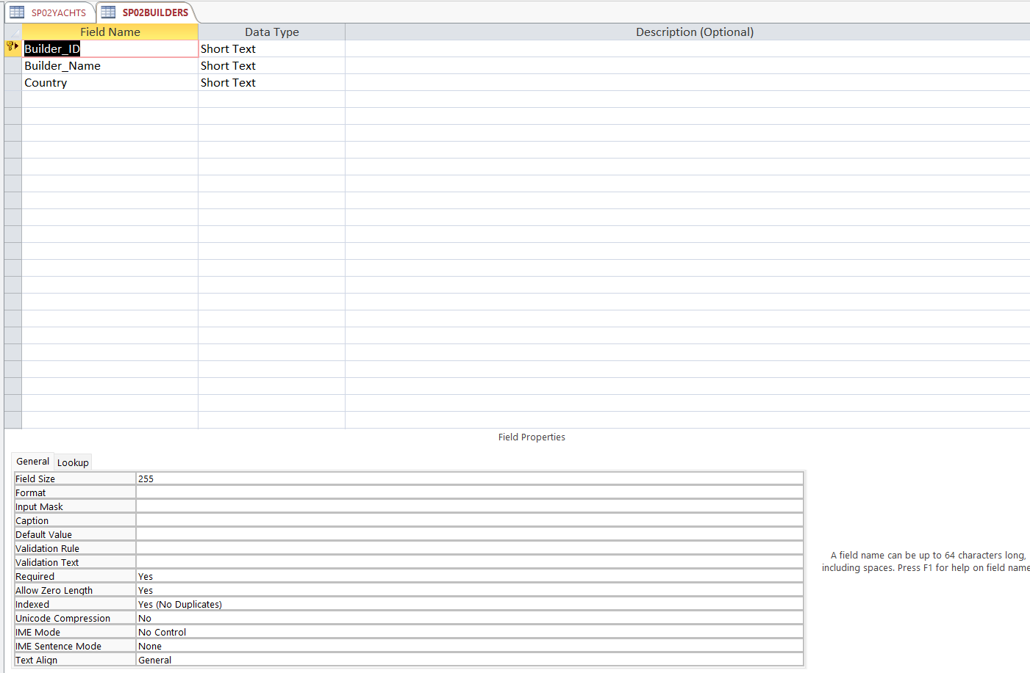
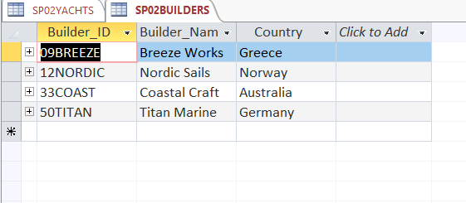

Q20: One-to-many Relationship between Builder_ID fields

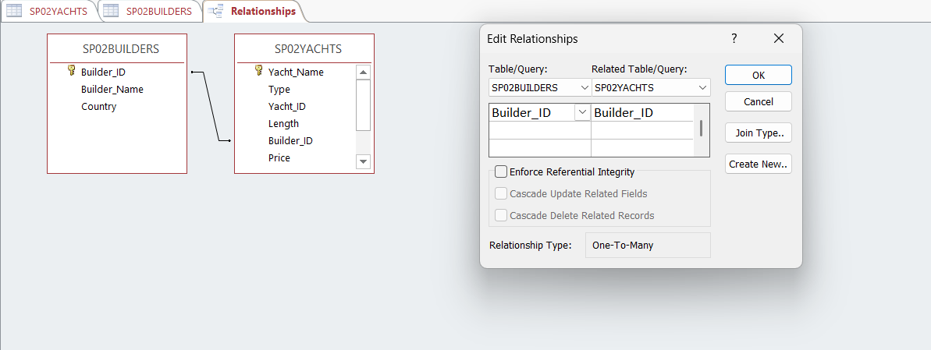

Q21-22: Report
- In attached PDF

